ETERNAL LOVE
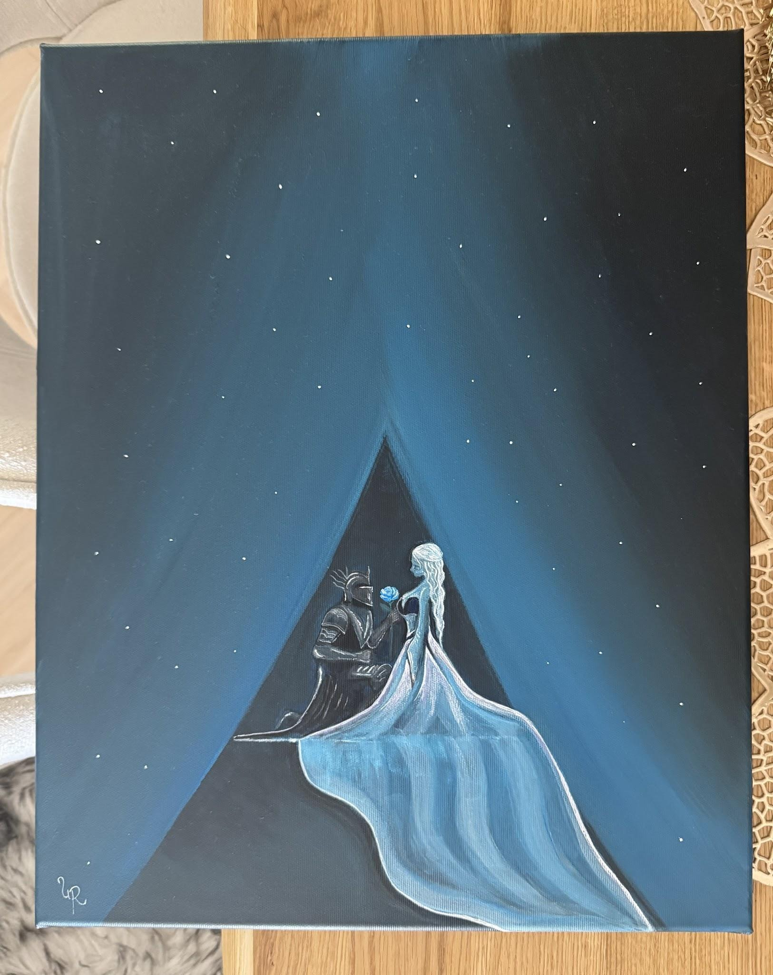

In a thousand different lifetimes,
beneath a thousand different skies,
I would still search for you.

I would find you
where the first rose awakens to the morning,
its beauty untouched by time—
for no flower has ever bloomed
as beautifully as your soul.

If fate made me a king,
I would lay every crown at your feet.
If it made me a wanderer,
I would cross every sea and every shadow
just to hold your hand for a single moment.

The stars may forget their places,
the moon may lose her light,
and centuries may turn kingdoms into dust,
but my heart would remember yours.

